Capstone Project 3 – Steel Defects Classification and Segmentation

Background and Problem Statement:

Artificial Intelligence and Machine Learning are transforming the manufacturing industry. According to the report released by World Economic Forum, these technologies will play significant roles in the fourth industrial revolution.

Major areas which can be benefited from this are:

* Maintenance Department
* Production Department
* Supply Chain Department
* Quality Control Department
* Industrial Safety Department

Deep learning has been proven to be superior in detecting and localizing defects using imagery data which could significantly improve the production efficiency in the manufacturing industry

Detecting defects would help in improving the quality of manufacturing as well as in reducing the waste due to production defects.

Aim and Data Source:

<https://www.kaggle.com/c/severstal-steel-defect-detection/data>

Data contains around 12600 images with 4 classes of defects, we aim to detect:

* Detect Whether the image has a defect or not.
* Classifying types of defects and localizing them with the help of a mask.

Feature Engineering & EDA:

We were given two files namely

* Defective images training data containing defective images name encoded mask pixels and classes of defects.

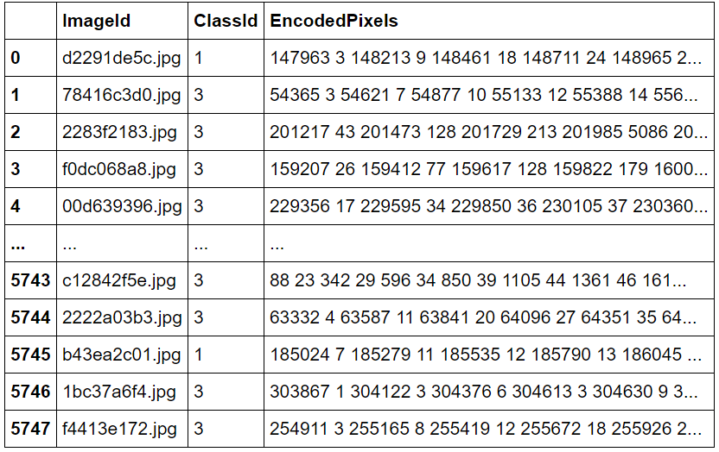

* All image’s data both defective and non-defective along with their labels.

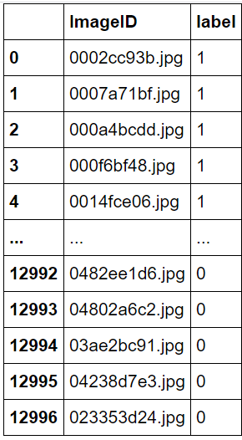

* Visualizing the Defective images dataset, we find out there is a class imbalance in the dataset with a prominent class being as a defect with class 3.

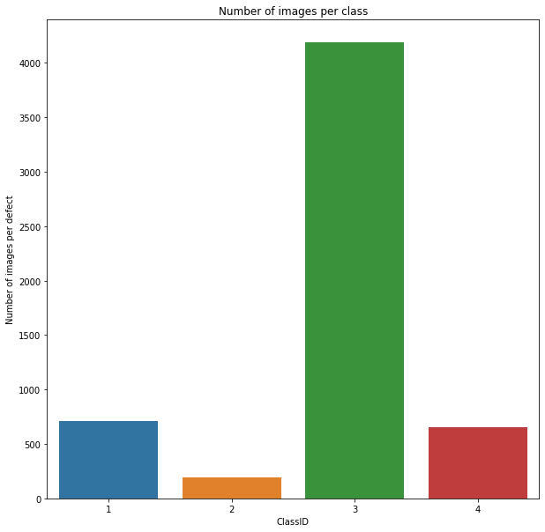

* Also, we would like to see that whether our images are having multiple defects or not plotting and doing the value counts we come to know that there are

1. 5201 images having only 1 defect
2. 272 images having 2 defects
3. 1 image having all the defects.

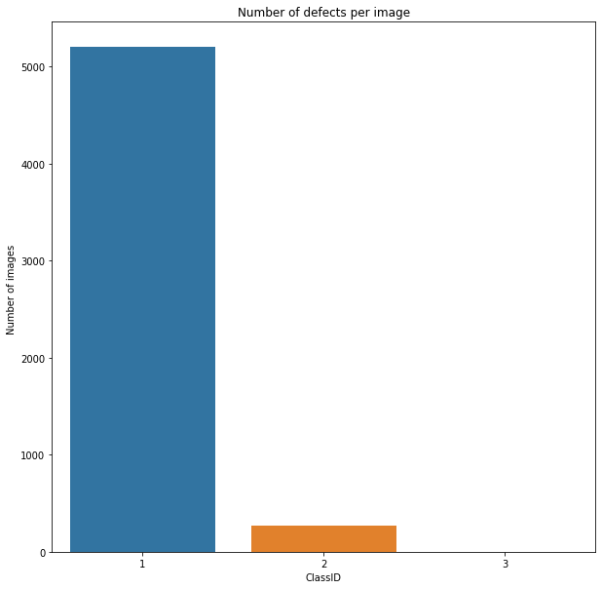

* Analysing All images file to find out no of images having defects

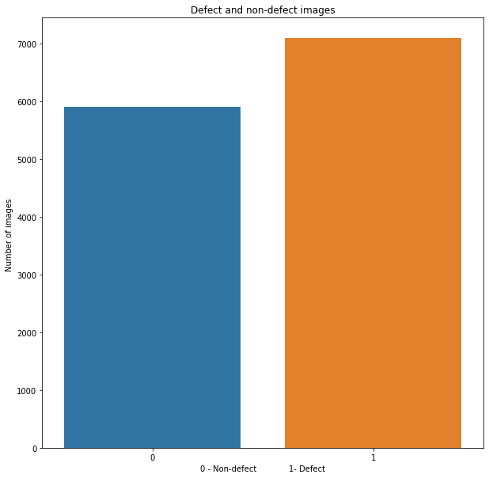

* There are around 7000 images with defects and nearly 5400 with no defects.
* For visualization of Defective images given the mask encoded pixels we have used run length encoding method to convert encoded pixels to image mask.

Run length Encoding Theory:

* Sometimes it is hard to represent a mask using an index as it would make the length of the mask equal to the product of height and width of the image
* To overcome this, we use a lossless data compression technique called Run-length encoding (RLE), which stores sequences that contain many consecutive data elements as a single data value followed by the count.
* For example, assume we have an image (single row) containing plain black text on a solid white background. B represents a black pixel and W represents white:

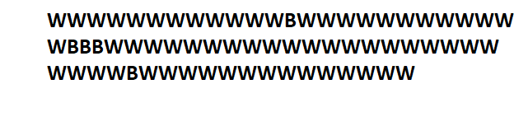

* Its run length encoding is 12W1B12W3B24W1B14W
* This can be interpreted as a sequence of twelve Ws, one B, twelve Ws, three Bs, etc.

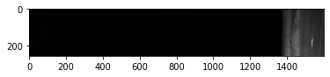

Before RLE encoding

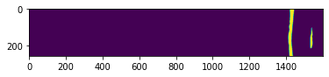

After RLE encoding

* As seen above we can now visualize the defects more clearly.
* We can further convert the image into RGB format using open cv.

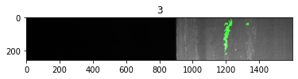

Model Preparation and Comparison:

* In the first step, we need to classify images into whether it's defective or not for this we have split the data into test and train with a ratio as 0.15 to 0.85.
* Also, we have used image augmentation by using an image data generator further splitting the data into training and validation datasets.
* Image augmentation was also performed for the test dataset.
* We have used base model as **ResNet** and have used the concept of transfer learning by using the pre calculated weights for Resnet model.

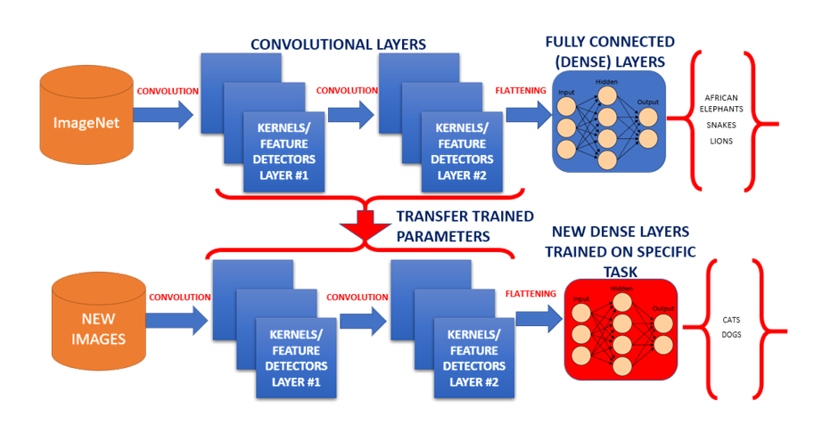

Overview of Transfer Learning

Model summary:

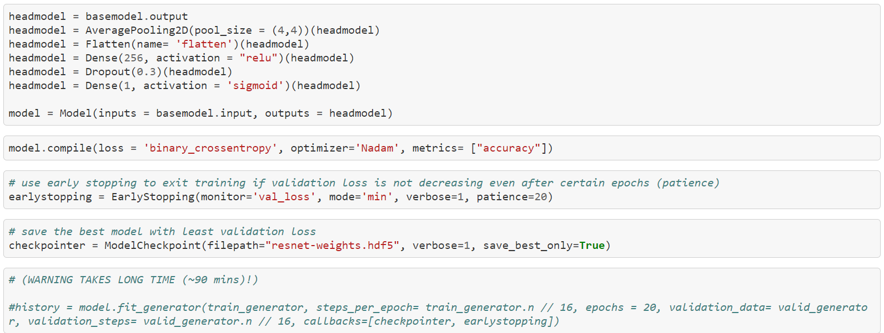

* After compiling and fitting the model an accuracy of 96.48% on train dataset and a validation accuracy of 91.57% was observed.

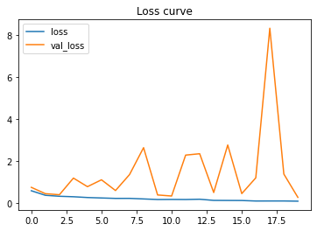 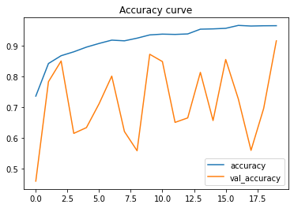

* The loss curve and accuracy curve for the model can be seen above.
* For the test data model, accuracy came out to be 88.42%.
* Classification Report and confusion matrix was as follows.

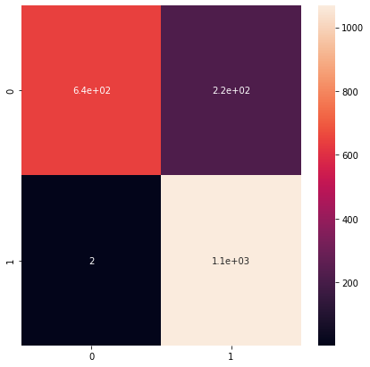

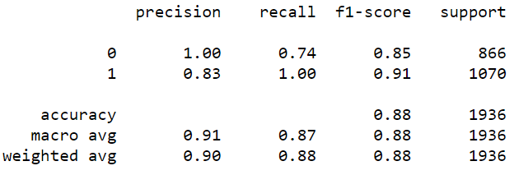

* For our second Aim of the project to do defect segmentation we have used

Res U-Net but before that less find out what is image segmentation?

What is image Segmentation?

* The goal of image segmentation is to understand and extract information from images at the pixel level.
* Image Segmentation can be used for object recognition and localization which offers tremendous value in many applications such as medical imaging and self-driving cars etc.
* The goal of image segmentation is to train a neural network to produce a pixel-wise mask of the image.
* Modern image segmentation techniques are based on a deep learning approach that makes use of common architectures such as CNN, FCNs (Fully Convolution Networks), and Deep Encoders-Decoders.
* In CNN for image classification problems, we have to convert the image into a vector and possibly add a classification head at the end.
* However, in the case of Unit, we convert (encode) the image into a vector followed by up sampling (decode) it back again into an image.
* In the case of Unet, the input and output have the same size so the size of the image is preserved.
* For classical CNNs: are generally used when the entire image is needed to be classified as a class label.
* For Unet: pixel-level classification is performed.
* U-net formulates a loss function for every pixel in the input image.
* The SoftMax function is applied to every pixel which makes the segmentation problem works as a classification problem where classification is performed on every pixel of the image

Reference:

<https://towardsdatascience.com/introduction-to-u-net-and-res-net-for-image-segmentation-9afcb432ee2f>

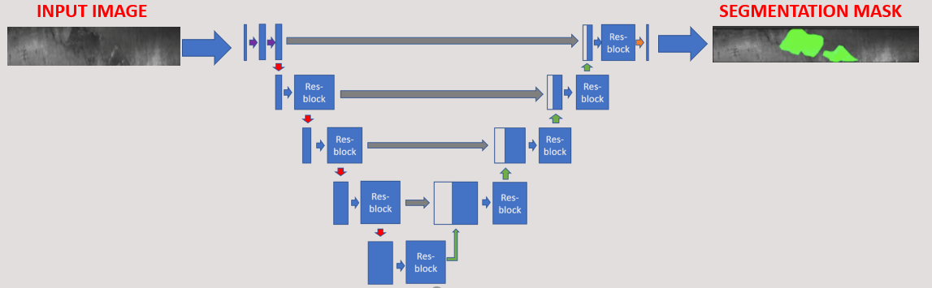

We need a custom loss function to train this ResUNet. So, we have used the loss function as it is from <https://github.com/nabsabraham/focal-tversky-unet/blob/master/losses.py>

Visualizing The results of Unet Segmentation Model

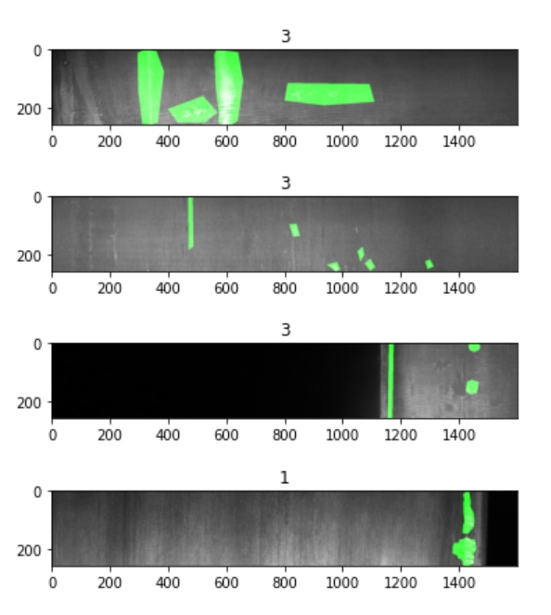 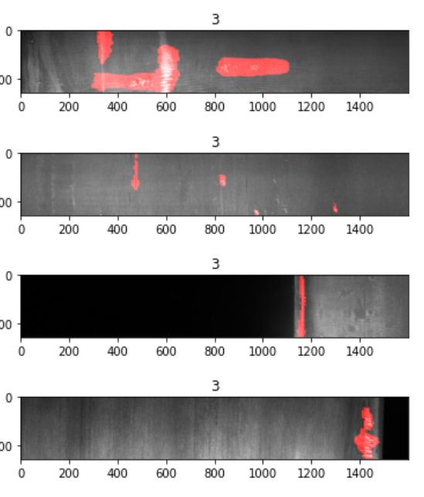

Train set Test Set

As seen from above in 4th image we have misclassified the class however we were able to correctly segment the defects.

Suggestions/ Future Research:

* Our model correctly identifies defective and non-defective images with 88% accuracy.
* For the segmentation model we need to come up with some metric to compare our test and training results both segmentation and class predictions.
* Furthermore, work needs to be done how can we put the model inro production for real time testing.
* Model Retraining approach can be applied for training the model for new images or new defects.